AWS CODE COMMIT

CICD PIPELNE

**How to create a simple pipeline that pulls code from a source repository and automatically deploys it to EC2 instance.**

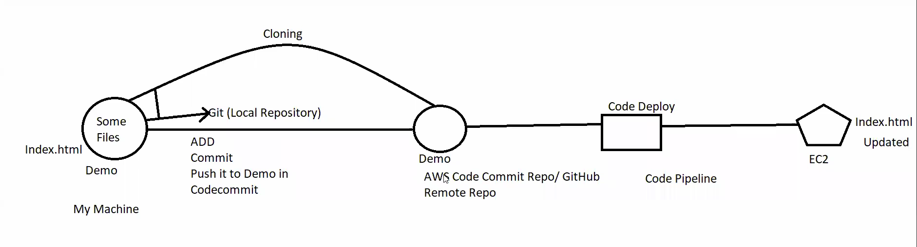

**Code Commit**

**1.Create a repository in code commit.**

**2.create a root user and give administrator access to it**

**3.Now open root user in incognito mode and open the repository in it and clone the url and copy https url :**

<https://git-codecommit.ap-south-1.amazonaws.com/v1/repos/My_Demo1>

**4.open git bash and change directory to the folder you want to clone**

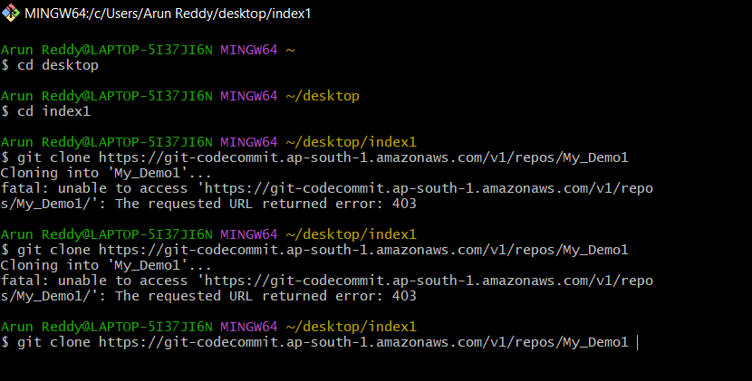

**5.give command git clone and paste the repository name (above url )**

**6.T will ask for credentials ,now go to AM Root user and under that open HTTPS credentials and give that in git bash**

**7.Now your remote repo and local repo are connected**

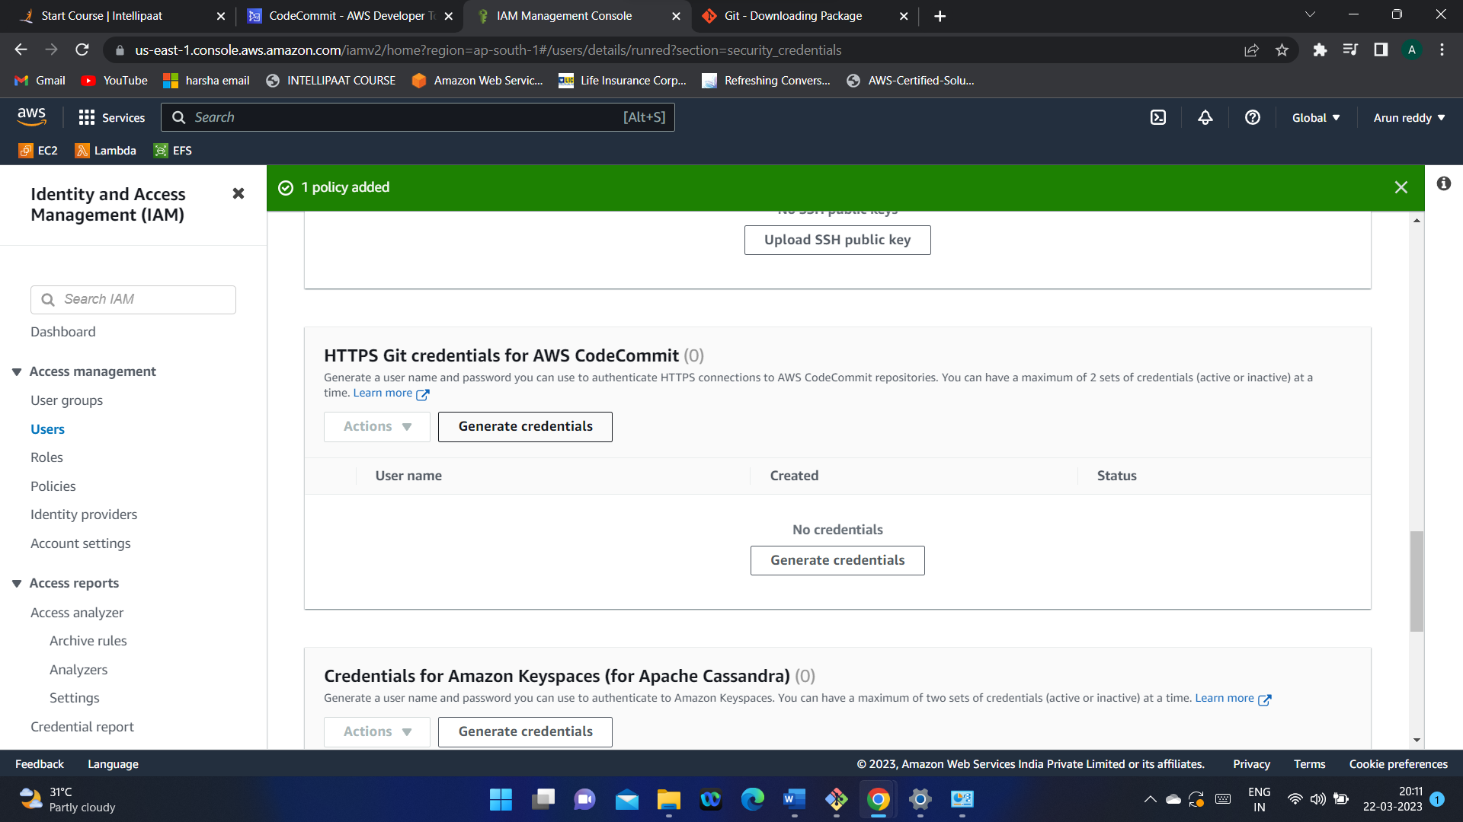

**8.Now copy the files in your folder1 folder to My_demo1 folder in local machine**

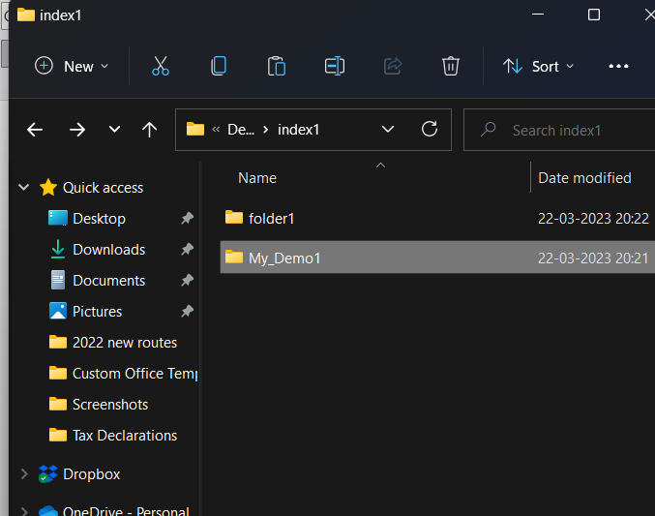

**9.Now change the directory in git bash to My_Demo1 and gve the following commands**

**git add -A -> to stage all your files at once**

**git commit -m “hi” -> to commit the code (-m specifies that we are giving some message, we can give the file name in our local repo or any random message” )**

**git push -> pushes the files to remote directory**

**10.Now you can see that flies in your local repository are cloned to remote repository.**

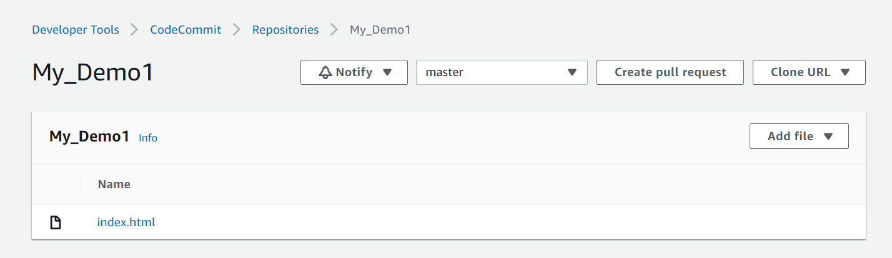

**EC2 instance with roles:**

1. **First create IAM roles**

**i)** [AmazonEC2RoleforAWSCodeDeploy](https://us-east-1.console.aws.amazon.com/iam/home#/policies/arn:aws:iam::aws:policy/service-role/AmazonEC2RoleforAWSCodeDeploy)

**ii)** [AmazonSSMManagedInstanceCore](https://us-east-1.console.aws.amazon.com/iam/home#/policies/arn:aws:iam::aws:policy/AmazonSSMManagedInstanceCore)

**2.Attach this role to a new EC2 instance**

**3.create a new role for EC2CodeDeploy under use case code deploy we will use it in next step**

**i)** [AWSCodeDeployRole](https://us-east-1.console.aws.amazon.com/iam/home#/policies/arn:aws:iam::aws:policy/service-role/AWSCodeDeployRole)

**4.In CodeDeploy create an application**

**A deployment group is a resource that defines deployment -related settings like which instances to deploy and how fast to deploy them.**

**After creating application create deployment group also, select service role which you have create for codedeploy**

**Now We are ready to create and run first pipeline. In this step, we create a pipeline that runs automatically when code is pushed to your codecommit repository.**

**Pipeline creation:**

**1.create a new code pipeline which includes Source as Code commit, and with deploy provider Code Deploy application name and deployment group as below** 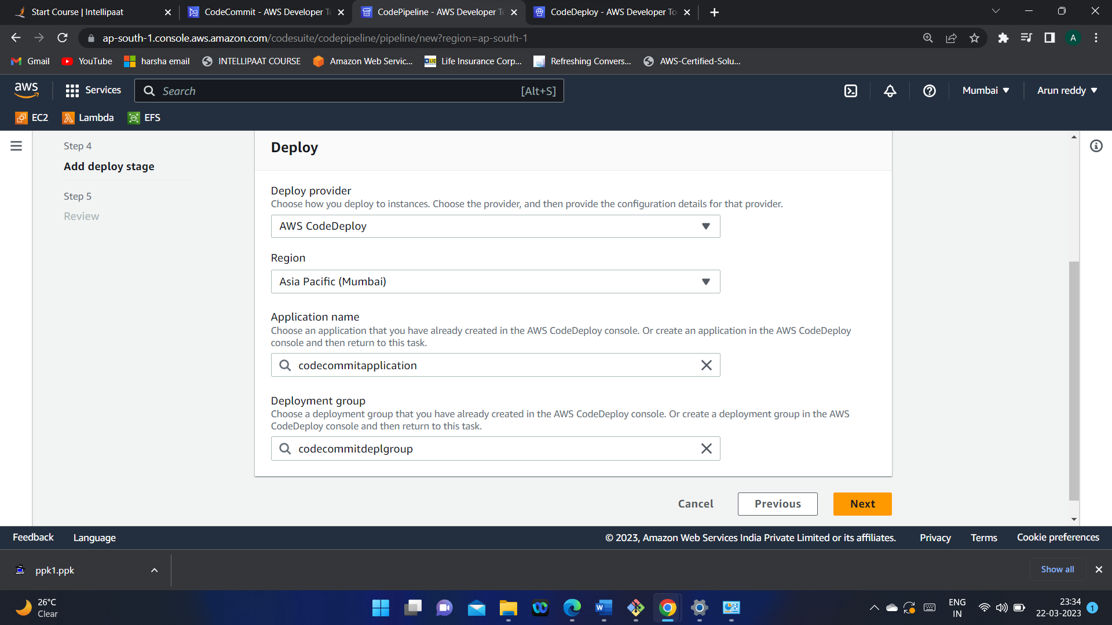

**2.After configuring the pipeline you get :**

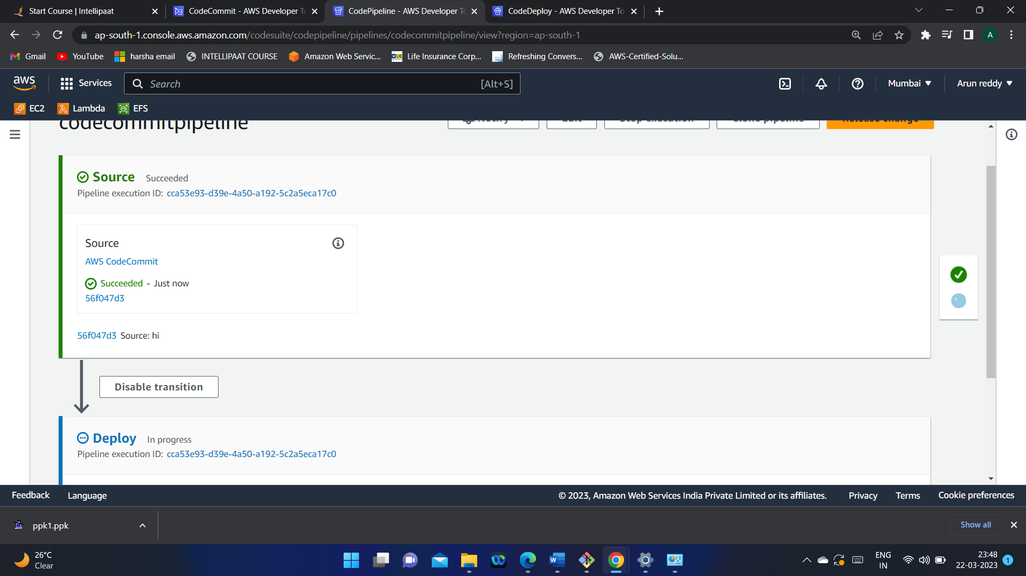

**So Here we can see that files from Source s fetched and will be deployed automatically into our EC2 instance**

**When you make changes n your local repo and do git commit and git push. It will be changed in Remote Repo and that change will be detected by pipeline and it will deploy again.**

**This process is continuous if you make changes continuously.**

**Some key terminologies:**

